**Create the web project**

1. In **Eclipse**,
2. Go to **Window** ==> **Perspective** ==> **Open Perspective**==> **Web**

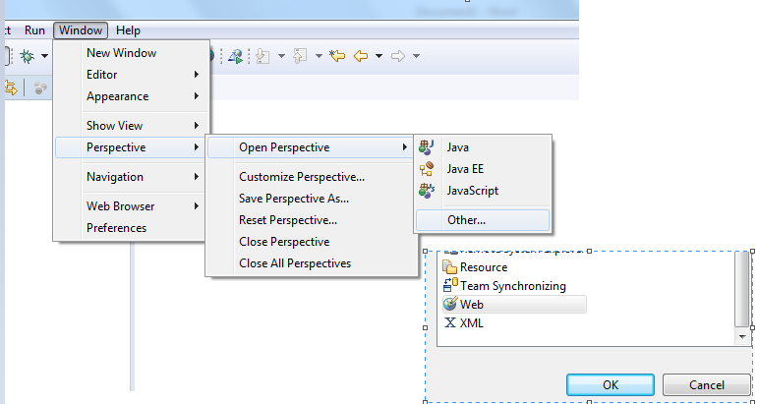

1. Select **File** / **New** / **Static Web Project**

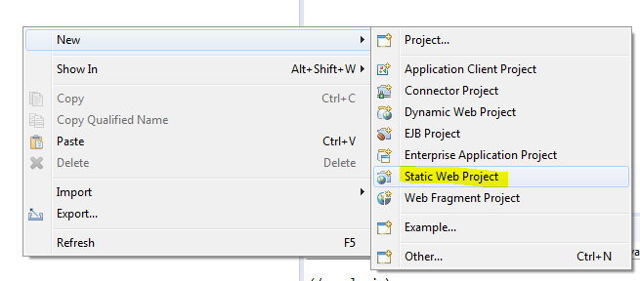

1. Choose a project name.

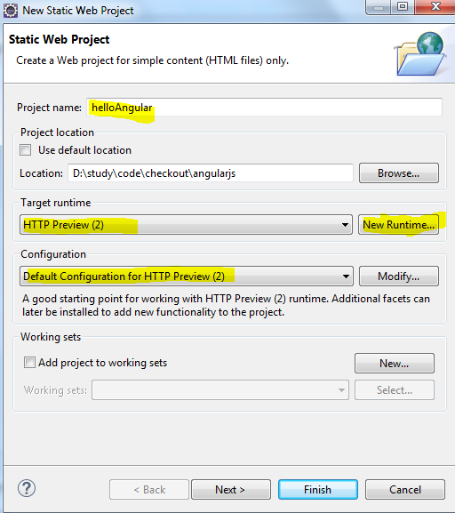

1. In the **Target Runtime** field, click the **New Runtime…** button
2. Select **Basic** / **HTTP Preview**. Make sure that you have selected the Preview and not HTTP Server.
3. **Check** (select) the box marked **Create a new local server**
4. Click **Finish**

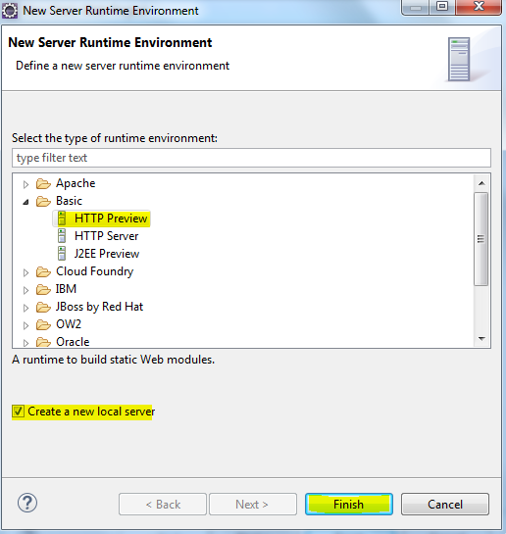

1. Click **Next**

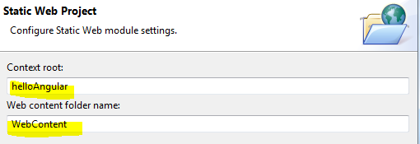

1. For **Context Root**, choose the url prefix you want.  For example, if you type /helloAngular, your web pages will appear at http://localhost:8080/helloAngular/…
   1. Note: you can’t leave this field blank
   2. Note 2: if you use / the web pages will appear at http://localhost//…  Note the double-slash.  That’s probably not what you want.
2. Click **Finish**

**Add your project to the web preview server**

1. In **Eclipse**, select **Window** ==> **Show View** ==> **Server**
2. **Right-click** on the **HTTP Preview** server and select **Add and Remove…**
3. In the resultant view, click on **your project’s name**
4. Click **Add**
5. Click **Finish**

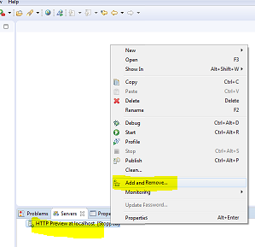

**Create your first web page**

1. In **Eclipse**,
2. In the **Project Explorer** pane, **expand** your project tree so that the **WebContent** folder is visible
3. **Right-click** on **WebContent** and select **New** ==> **HTML File**
4. For **File Name**, type a name of your choice.  For example, **index.html**
5. Click **Next**
6. **Finish**
7. In the open html window, add a **title** and **body**
8. **Save** the html file

**Test your web page**

1. In the **servers** pane,
2. **Right-click** on the **HTTP Preview** server and select **Debug**
3. Browse to your html file: **http://localhost:8080/helloAngular/index.html**  The url of the file consists of
   1. http://localhost:8080 = the **host** and **port** the server is running on.  You can find the port number in the console output. Something like Started 5:19:20.712:INFO:oejs.AbstractConnector:main: Started ServerConnector@5d3411d{HTTP/1.1,[http/1.1]}{0.0.0.0:8080}
   2. helloangular = the **Context Root** you set earlier
   3. index.html = the **file name** of your html file
4. The browser should show the title and body that you added earlier.
5. Project structure:

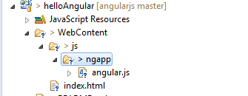

1. Output

